**Jaipur Engineering College and Research Centre, Jaipur**

**A**

**REPORT**

**ON**

**INDUSTRIAL VISIT**

**at**

**KOTA SUPER THERMAL POWER STATION**

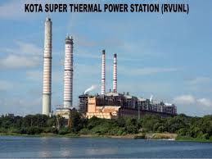

**Date of Visit: 06th September 2017**

**Faculty co-ordinators**

Mr. Shailendra Shrivastava Total No. of Students: 53

Mr. Rahul K. Malee Branch: Electrical Engineering

Ms. Ravita Saraswat Class: B. Tech. 3rd Year

As per Rajasthan Technical University (RTU) curriculum, the Jaipur Engineering College and Research Centre, Jaipur have to arrange an industrial visit for B. Tech 3rd Year Electrical Engineering students. Accordingly, we have requested the Superintendent Engineer, Kota Super Thermal Power Station, through mail for giving permission for one day. In response to this message Superintendent Engineer, Training Cell, Kota Super Thermal Power Station, have send their confirmation for one day visit on 06th September, 2017, we were started industrial visit from Jaipur Engineering College and Research Centre, Jaipur campus with Assistant Professor Mr. Shailendra Shrivastava, Mr. Rahul K. Malee, Ms. Ravita saraswat with 53 students of Electrical Engineering 3rd year Section A & B. at 6:00 a.m. by a bus. We reached Kota Super Thermal Power station at around 10.30 a.m. Assistant Engineer (Training), Mr S.K. Madan of Kota Super Thermal Power Station was demonstrated the different areas inside the plant.

At KSTPS, the students learnt about the power generation process and new technologies. They collected information on the social aspects of the project, viz capacity of KSTPS, units of power generated, its supply and distribution. The students learned about the management of Thermal power generation under varying availability of coal and varying demand. During the Kota Super Thermal Power station visit, students also visited the Geparnath Mahadev Temple and Hanging Bridge. We are return back to the Jaipur Engineering College and Research Centre, Jaipur at 11.55 PM. The students give the thanks to head of department and staff members of electrical engineering for organizing such a pleasant industrial visit.

**Brief about Kota Super Thermal Power Station**

Location Kota, Rajasthan, India

Commission date 1983

Operator(s) RVUNL

Type of plant Thermal power station

Primary fuel Coal-fired

Units operational 7

Details of units 110x2, 210x3, 195x2 MW

Installed capacity 1240.00 MW

Thermal power generation plant or thermal power station is the most conventional source of [electric power](https://www.electrical4u.com/electric-power-single-and-three-phase/). Thermal power plant is also referred as coal thermal power plant and steam turbine power plant.

A power generation plant mainly consists of [alternator](https://www.electrical4u.com/alternator-or-synchronous-generator/) runs with help of steam turbine. The steam is obtained from high pressure boilers. Generally in India, bituminous coal, brown coal and peat are used as fuel of [boiler](https://www.electrical4u.com/steam-boiler-working-principle-and-types-of-boiler/). The bituminous coal is used as boiler fuel has volatile matter from 8 to 33% and ash content 5 to 16%. To increase the thermal efficiency, the coal is used in the boiler in powder form.

In coal thermal power plant, the steam is produced in high pressure in the steam boiler due to burning of fuel (pulverized coal) in boiler furnaces. This steam is further supper heated in a super heater. This supper heated steam then enters into the turbine and rotates the turbine blades. The turbine is mechanically so coupled with alternator that its rotor will rotate with the rotation of turbine blades. After entering in turbine the steam pressure suddenly falls and corresponding volume of the steam increases. After imparting energy to the turbine rotor the steam passes out of the turbine blades into the condenser. In the condenser the cold water is circulated with the help of pump which condenses the low pressure wet steam. This condensed water is further supplied to low pressure water heater where the low pressure steam increases the temperature of this feed water, it is again heated in high pressure.

For better understanding we furnish every step of function of a thermal power station as follows,

1. First the pulverized coal is burnt into the furnace of steam boiler.

2. High pressure steam is produced in the boiler.

3. This steam is then passed through the super heater, where it further heated up.

4. This supper heated steam is then entered into a turbine at high speed.

5. In turbine this steam force rotates the turbine blades that means, in the turbine the stored potential energy of the high pressured steam is converted into mechanical energy.

6. The turbine is coupled with alternator and alternator generates the electricity.

**Line Diagram of Power Plant**

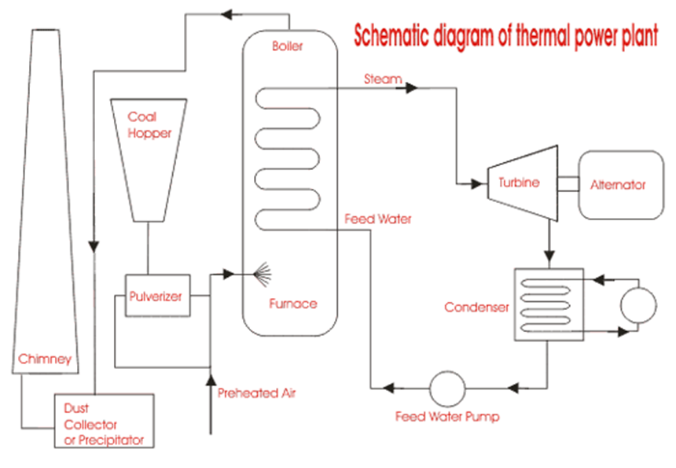

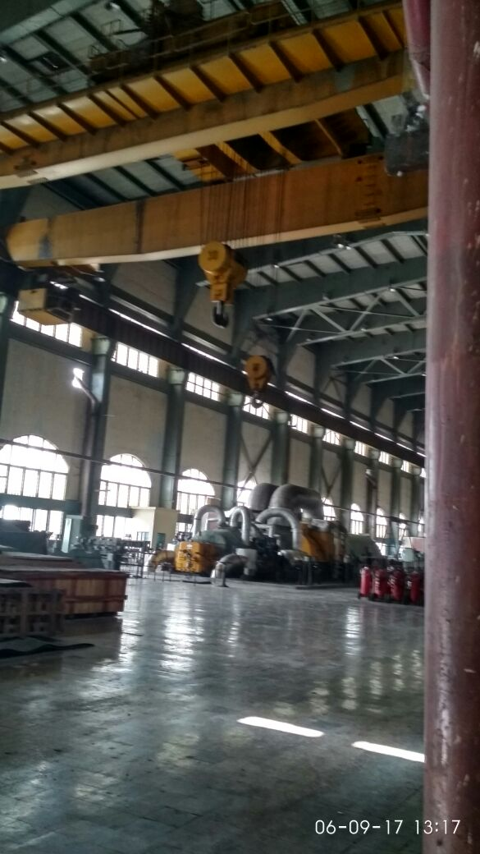

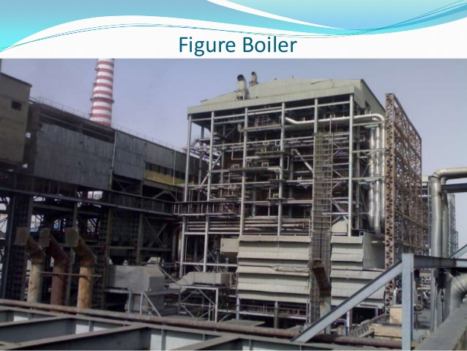

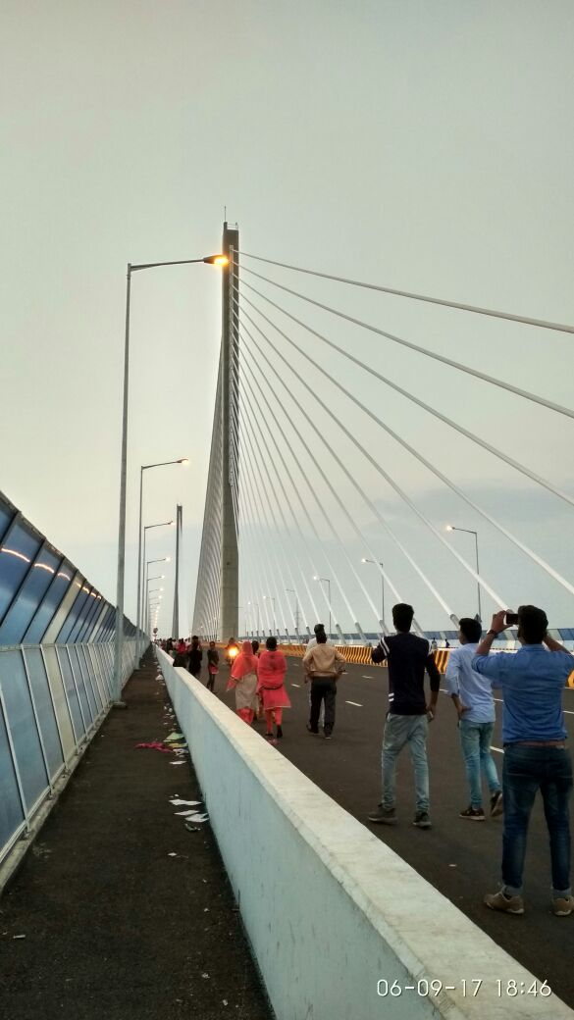

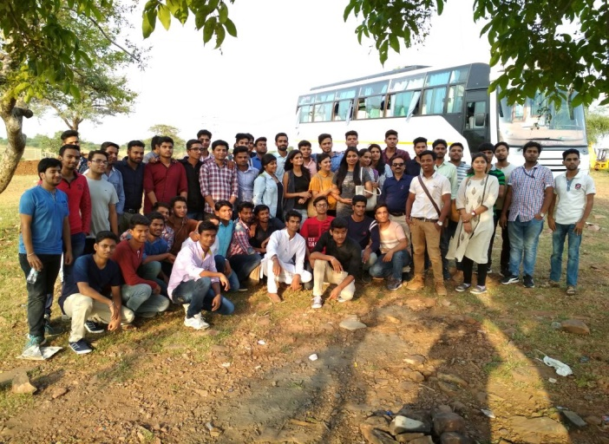

**Jaipur Engineering College and Research Centre, Jaipur**

**Department of Electrical Engineering**

**Semester – V**

**List of students for Industrial Visit at KSTPS, Kota**

|  |  |
| --- | --- |
| **S.No.** | **NAME OF STUDENTS** |
|  | ANJANI KUMAR SINGHAL |
|  | AYUSH AGARWAL |
|  | KRISHNA K.MEENA |
|  | HEMANT SINGH |
|  | JASWANT SINGH |
|  | KESHAV MAHESWARI |
|  | KUSHAL CHOUHAN |
|  | NAVNEET GOYAL |
|  | ARPIT K.JAIN |
|  | KRISHNA KUMAR PRAJAPATI |
|  | KULDEEP JAIN |
|  | KUNAL BANSHIWAL |
|  | LAXMIKANT SAINI |
|  | MAHESH KHEDIA |
|  | MAYANK GUPTA |
|  | MOHIT SAINI |
|  | NIKHIL SAHU |
|  | PANKAJ KUMAR SHARMA |
|  | PRAKHAR JOSHI |
|  | PRIYA BAMBANI |
|  | PRIYANSH JAIN |
|  | RAHUL K. AGRAWAL |
|  | RAHUL SHARMA |
|  | RANJEET SINGH |
|  | RISHAV KUMAR |
|  | RITESH KUMAR JAIN |
|  | RITESH KUMAR SHARMA |
|  | ROHIT JOSHI |
|  | SACHIN JAIN |
|  | SAKSHAM GARG |
|  | SAKSHI GUPTA |
|  | SANGEETA SHARMA |
|  | SAURABH SONI |
|  | SHAKTI P. S. CHAUHAN |
|  | SHUBHAM KASHYAP |
|  | SHUBHAM MISHRA |
|  | SOURABH SHARMA |
|  | TABISH AKHTAR |
|  | UJJWAL SONI |
|  | VAIBHAV CHOUDHARY |
|  | VAIBHAV JAIN |
|  | VENUGOPAL GAUTAM |
|  | VIPIN KUMAR |
|  | ZEESHAN AHMAD ANSARI |
|  | YOGESH SHARMA |
|  | PRACHI VYAS |
|  | BHARTI SHARMA |
|  | VIKASH PARASHAR |
|  | ROHIT SHARMA |
|  | ROHIT BAGADIA |
|  | TARUN GARG |
|  | VINOD K.YADAV |
|  | ETI SHARMA |

We also wish to express our sincere thanks to the principal of JECRC and The JECRC management for providing permission and encouragement for Industrial visit.

**Faculty co-ordinators**

Mr. Shailendra Shrivastava

Mr. Rahul K. Malee

Ms. Ravita Saraswat

Department of Electrical Engineering